List’s in the Collection’s?

1. ArrayList
2. Vector
3. Linked List

In this today’s Article we Focus on **ArrayList** only after this Article another article’s are comes on vector and Linked List.

So, let’s go with ***ArrayList***

**01]. ArrayList**

* Arraylist have fast iteration and random access.
* This is an ordered collection by index.
* This is not sorted.
* ArrayList maintain the insertion order.
* This also accepts the duplicates values.



Now, we will see two example’s with code:

01]. How to create and use an ArrayList ***with*** mention it’s size.

02]. How to create and use an ArrayList ***without*** mention it’s size.

01]. How to create and use an ArrayList ***with*** mention it’s size.

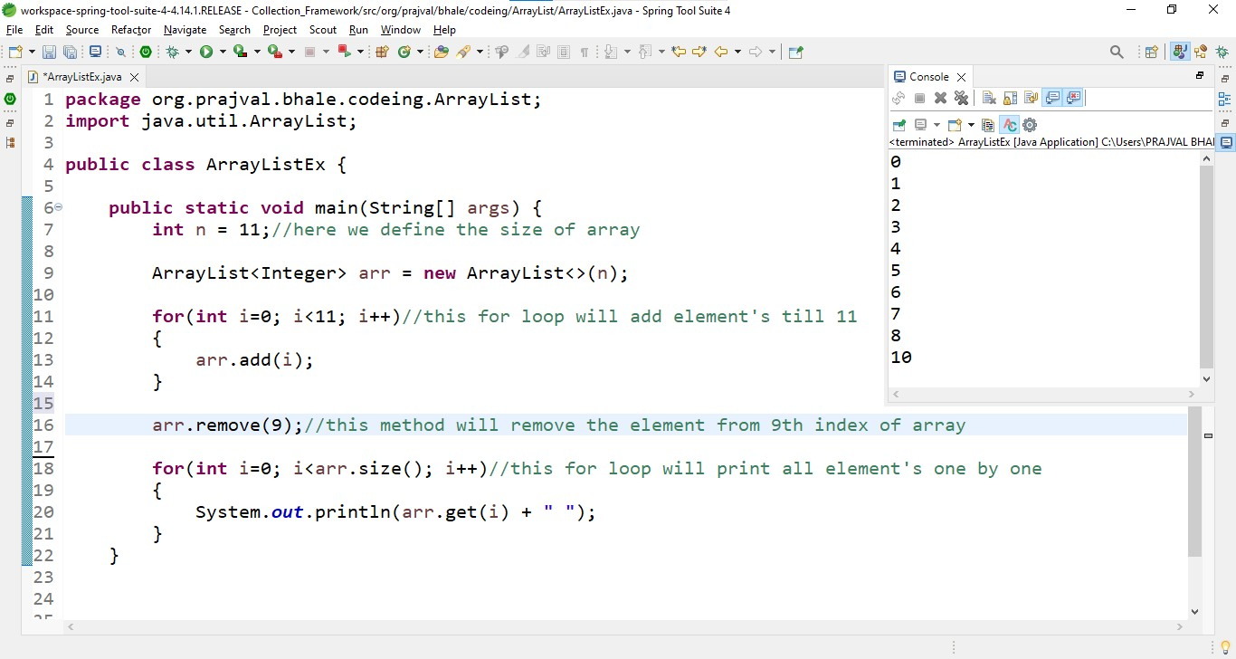

02]. How to create and use an ArrayList ***without*** mention it’s size.

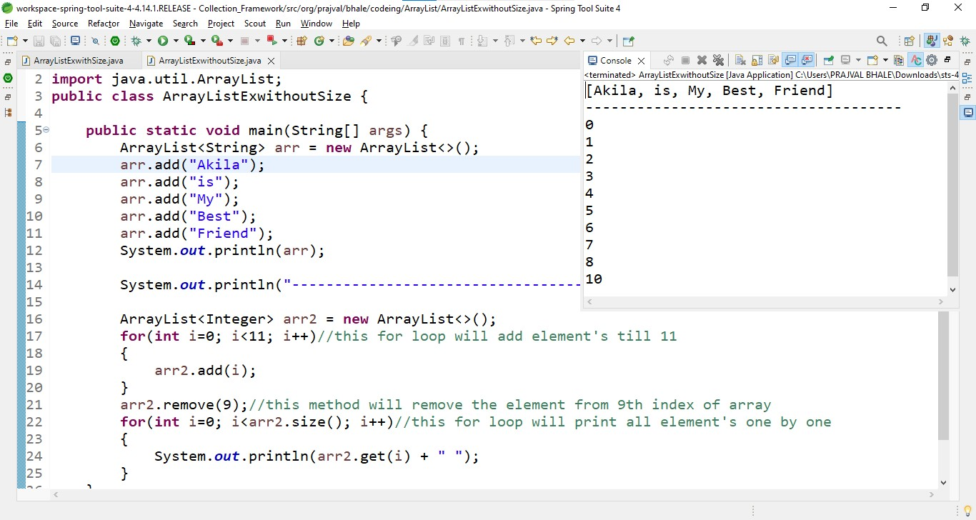

Some important about ***ArrayList***

1. arraylist inherit the AbstractList class and implement the list interface.
2. Arraylist must be initialized by size.
3. Arraylist cannot be used for primitive type.
4. Arraylist is not synchronized.

Now, we will see some operations on arraylist:

1. Adding Elements
2. Change the Elements
3. Removing the Elements
4. Iterating the Elements
5. Adding

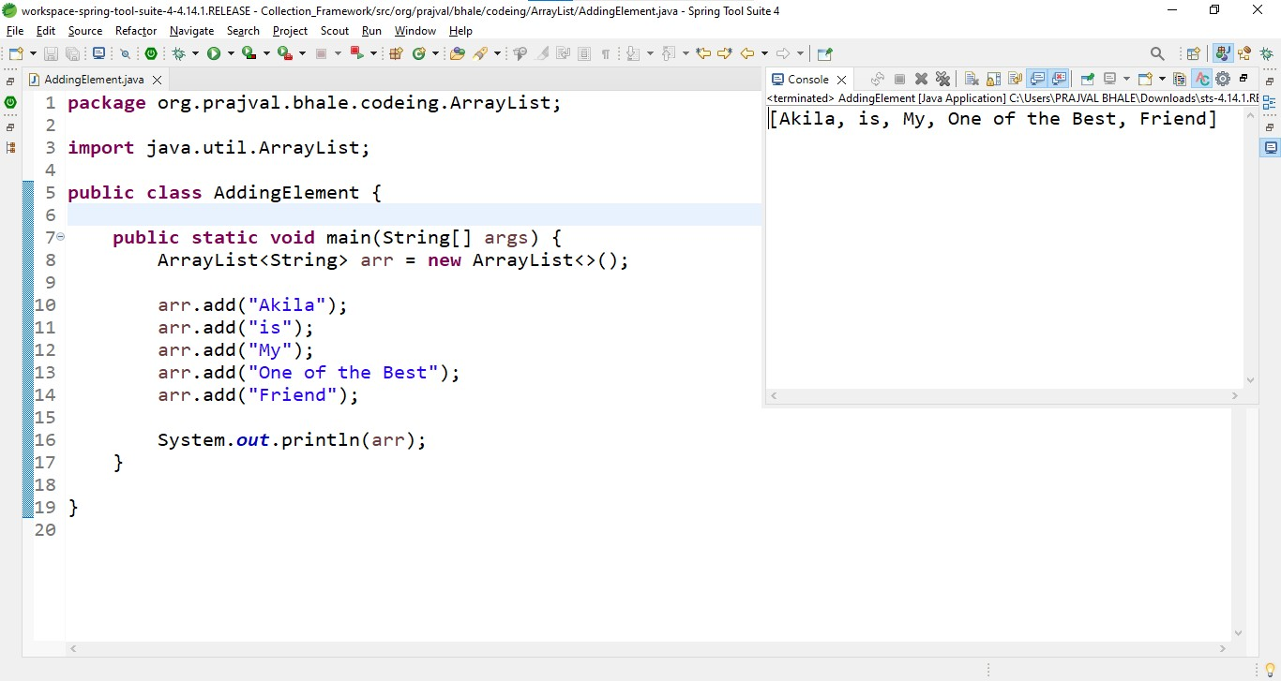

1. Change

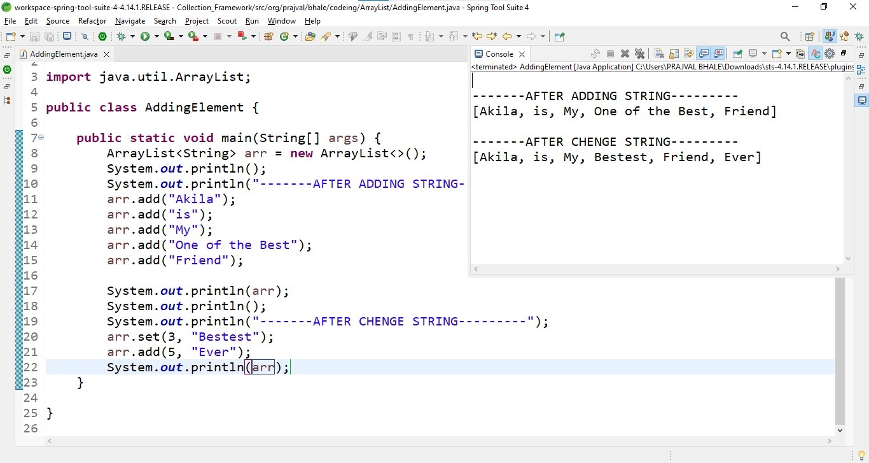

1. Removing

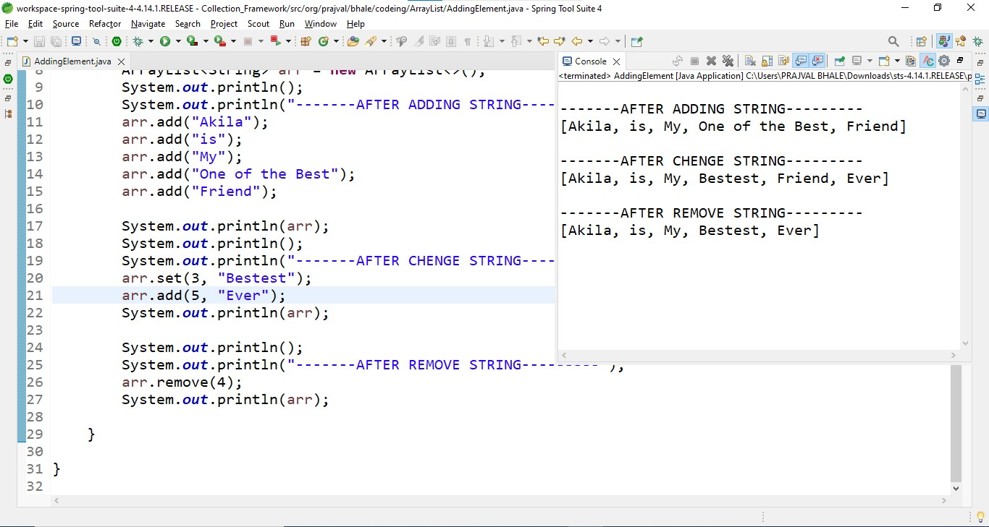

1. Iterating

